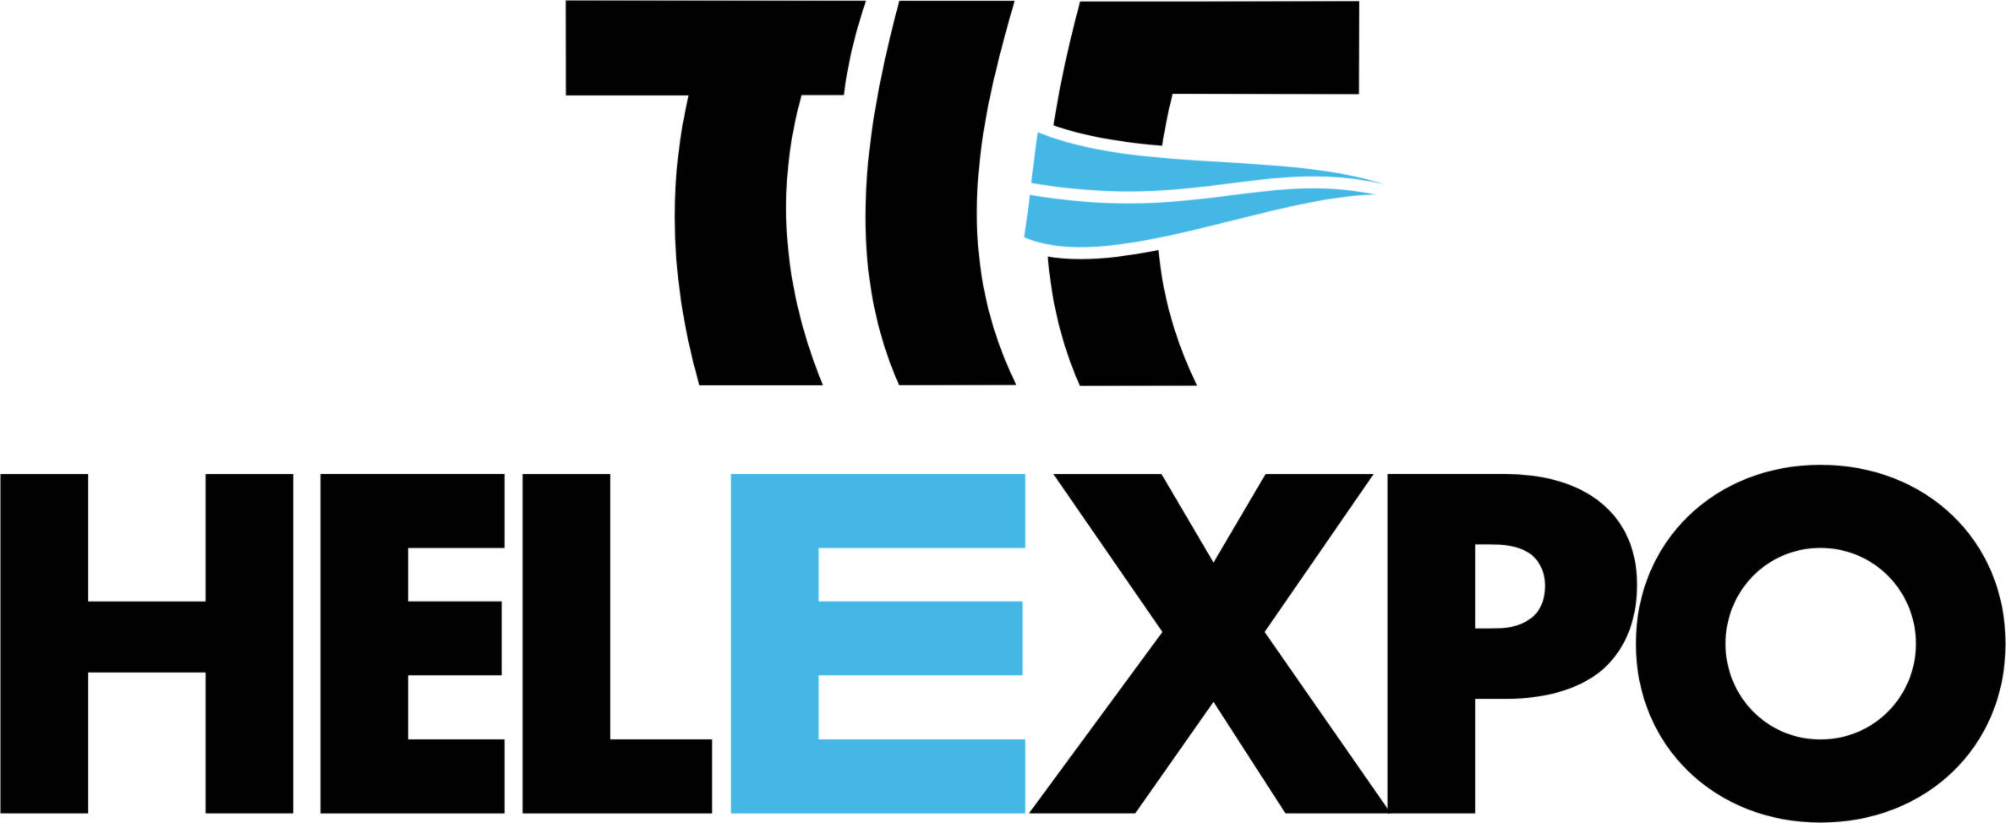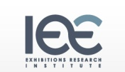

HOSTED BUYERS PROGRAM : Fix your appointments, NOW!

WHAT IS IT?
It is a service provided by HELEXPO to exhibitors and visitors, based on the promotion of cooperation among businesses, through pre-arranged business meetings. Companies participating in HELEXPO field exhibitions will have the opportunity to meet exhibitors, thanks to a customized software program, where business meetings can be pre-arranged within the exhibition area. This is achieved through a state of the art electronic system.

WHY SHOULD YOU PARTICIPATE?

- You ensure your business meetings (face to face) with companies of your choice
- You have better control of the time spent at the Fairgrounds
- You open new business opportunities
- You get acquainted with products and services which are 100% relevant to your business activities
- You find the appropriate colleagues in your field
- You exchange knowledge in your business area of interest
- You arrange your appointments according to your needs

HOW TO REGISTER

- You must fill in the forms : “Trade Visitor’s Requested Data”, “Co-operation Profile”
- The forms must be sent to the Commercial & Economic Section of the Greek Embassy in your country, with c.c. to HELEXPO, or directly to HELEXPO at: kostopoulou@helexpo.gr , skoulikaraki@helexpo.gr.
- An evaluation of your application by HELEXPO will follow. Please note that a first-come-first-served order will be followed for all applications.
- If accepted as hosted buyer, you shall receive a User Account from HELEXPO as well as directions on how to proceed with the pre-arrangement of your appointments with our exhibitors, through our on-line B2B Program. A minimum of 12 appointments per Hosted Buyer is a prerequisite for the final confirmation of your participation in the Program. Furthermore, HELEXPO maintains the right to additionally arrange another 5-10 appointments for you, according to your fields of interest and our exhibitors’ requests.
- Your accommodation and/or flight arrangements shall be settled by HELEXPO.
- Your transfer from and to the airport as well as from the hotel to the fairgrounds and back will be arranged by HELEXPO.
- In case of non confirmation of your visit (hotel & air ticket) and your B2B appointments latest ten days prior to the opening of the exhibition your participation in the Hosted Buyers Program will automatically be cancelled (as will also be the case for your air-ticket and hotel bookings)
- In case you require an Invitation Letter for VISA purposes, HELEXPO will provide it to you, as long as you inform us accordingly two months prior to the exhibition you shall be visiting. In case you already have a VISA, you shall be requested to send a copy to HELEXPO together with the forms to be filled in.
- Printed material as well as your entrance badge shall be available at your hotel, upon arrival.
- Our executives will provide any necessary assistance and information to you during your visit at the exhibition.
- Before leaving the Fairgrounds, you shall be asked to fill in a respective questionnaire with regards to your visit.

Take advantage of the opportunity HELEXPO is offering free of charge, to ensure successful business contacts and partnerships, combining work with pleasure and added value services, in a rich and hospitable exhibition environment. Further details on your visit will be sent to you in due time.

We wish you every success in your business transactions and are looking forward to welcoming you at our premises!

